Industry Outlook: Sectors Minimally Disrupted by Generative AI

Overview
This report aims to highlight the sectors that remain resilient to the disruption of generative AI. These industries continue to rely on human skills, regulatory oversight, and localized operations that limit the use of automation. This analysis highlights why the pace and extent of AI-driven transformation remain slower in these areas and explores their sector-specific challenges and opportunities through 2035.

Executive Summary
Rising investment and adoption of generative AI across industries have heightened both optimism and anxiety among market participants. However, several sectors—such as traditional agriculture, basic raw materials extraction, artisanal and craft industries, and segments of primary healthcare—are retaining their business models and workflows with minimal AI-driven change. These industries rely on labor-intensive skills, unquantifiable judgment, or face regulatory strictures that challenge data-centric automation. The fundamentals of manual skill, compliance, and locality are underpinning continued stability and gradual evolution rather than rapid AI-fueled disruption.

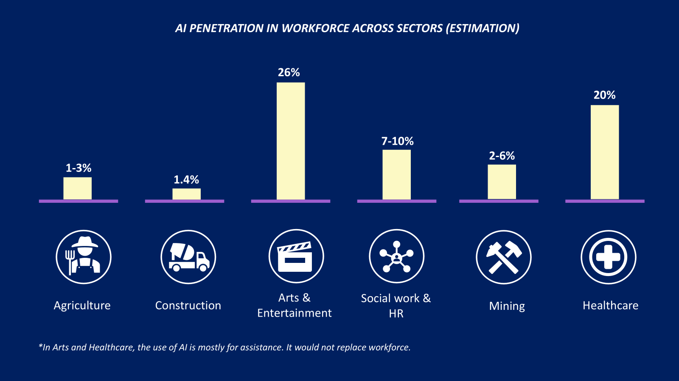Sector Outlooks
Generative AI is transforming many industries, yet certain sectors continue to demonstrate robust resistance due to a blend of manual skill requirements, regulatory complexity, physical/local constraints, and consumer preference for authenticity.

1. Agriculture
Market Overview: The global agriculture sector will grow from $12.12 trillion in 2024 to $12.97 trillion in 2025, at a CAGR of 7%. In India, agriculture is projected to reach INR 236.6 trillion ($2.8 trillion) by 2033, at a CAGR of over 10%. Gartner’s 2025 industry analysis reports that barriers to end-to-end automation are pronounced, driven by fragmented farm sizes, local climate, and physical unpredictability.
Subsectors & Rate of AI Penetration:
- Precision Agriculture (Large/Commercial Farms): Over 50% of large farms in developed markets are projected to use precision AI (remote sensing, automated irrigation, drone analysis, yield predictions), up from ~25%-30% in 2020. Adoption in small/medium farms is rising, but lags at 20–25%; manual labor remains crucial, especially in emerging economies.
- Livestock & Dairy Operations: AI-powered monitoring (e.g., health wearables, automated feeding) is present in 8–14% of large facilities, but <2% of global herd management is fully automated; clinical diagnostics, breeding, and feeding remain largely human-driven.
- Post-Harvest & Supply Chain: Warehouse robotics, smart sorting, and logistics automation reach 10–15% adoption in major agribusiness; most rural logistics still manual.
AI Penetration: AI applications (e.g., precision farming, crop health monitoring, yield prediction) are growing rapidly, with the AI in agriculture market size expected to reach $5 billion globally in 2025, up from $2 billion in 2023—over 20% CAGR. However, this remains a small fraction (less than 0.1%) of total global agriculture revenue, especially in smallholder-dominated regions where adoption is slow. Gartner forecasts overall AI-driven activities at 1–3% of daily workflows globally, dominated by larger, well-capitalized enterprises.
Resilience Factors:
- Heavy reliance on manual labor, context-specific decision-making, and real-time adaptation to unpredictable variables (weather, pests, terrain).
- Capital constraints and digital divide in rural areas impede rapid, uniform AI adoption.
- Localized knowledge and hands-on skills remain irreplaceable even as AI supports efficiency.
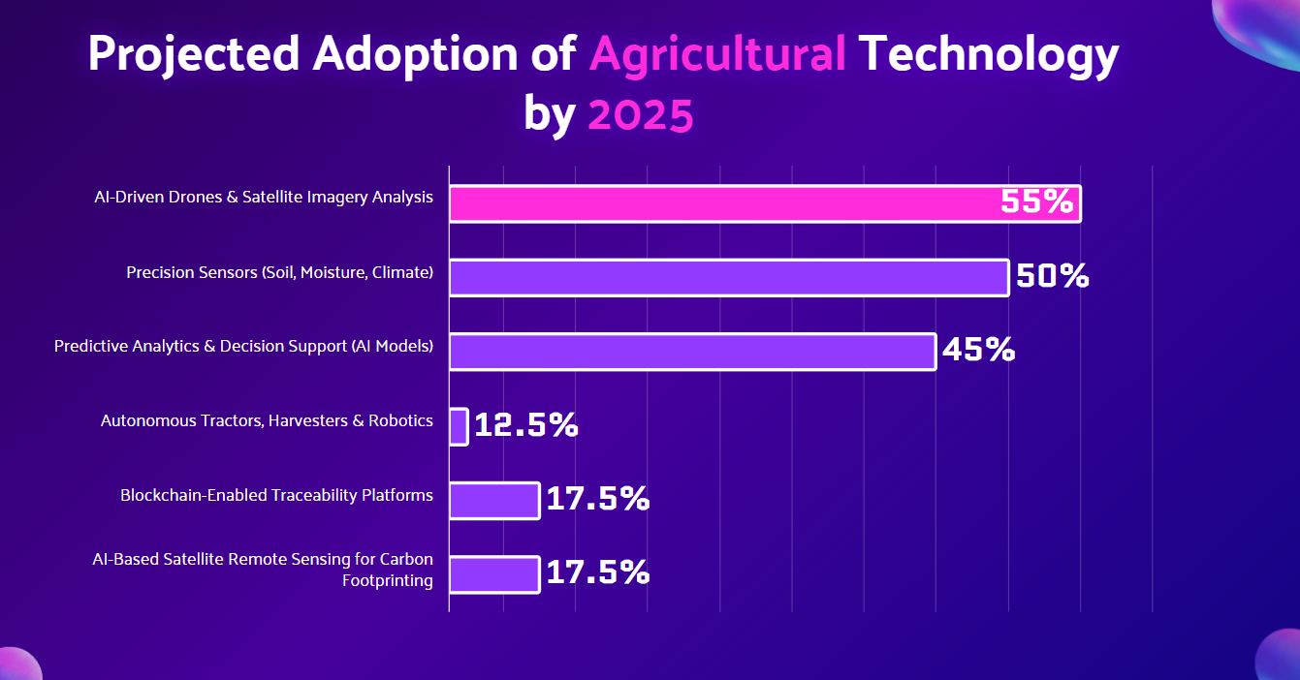
2. Construction
Market Overview: The global construction sector exceeds $12 trillion in value and is growing as economies urbanize. AI is being piloted in planning (design automation), logistics, and quality control. AI adoption is increasing, with the AI in construction market projected to reach approximately $17 billion by 2029 at a CAGR of 26%-33%.
Subsectors & Rate of AI Penetration:
- Design, Architecture, & Planning: Gartner projects 20–28% of large engineering and architectural firms use generative AI for BIM, design simulation, and code compliance—but rates fall below 8% for SMEs (small and medium enterprises).
- On-site Automation & Robotics: The introduction of robotics on-site may reduce errors and costs, leading to significant penetration, particularly in flagship projects in developed countries.
- Safety & Regulatory: AI-powered safety systems and compliance monitoring prevent accidents up to 25% but still reach up to 8% of large builds; manual inspection is dominant elsewhere.
AI Penetration: Reports cite overall workflow penetration at approximately 1.4%, among the lowest of all sectors tracked. Practical AI deployment in construction remains limited and is concentrated in larger firms, urban areas, and new builds. The physical, fragmented nature of construction, diverse project settings, and regulatory oversight slow full automation.
Resilience Factors:
- High dependency on skilled manual labor (e.g., masonry, carpentry), on-site adaptation, and local regulations.
- Projects are heterogeneous and not easily standardized for AI or robotic takeover.
- Physical safety, inspection, and environmental assessments require human oversight.
3. Arts, Entertainment & Creative Industries
Market Overview: The global media and entertainment industry is projected to reach $3.5 trillion by 2029 at a 3.7% CAGR, yet the core value remains rooted in human creativity, original performance, and audience connection, where generative AI’s role would mainly be enhancing productivity rather than replacing creative leadership.
Subsectors & Rate of AI Penetration:
- Film & Animation: About 30% of production houses use generative AI for asset creation and scripting, but only ~7% of total creative direction and curation are automated.​
- Music Production: AI-powered mastering and sound synthesis are present in 15–25% of studio workflows; live performance, composition, and artist branding remain almost entirely human-driven.
- Publishing & Design: 20–35% usage in copywriting or digital design drafting, but final creative judgment rests with human teams.
- Live Performance, Fine Arts, Events: AI influence is negligible (<2%) in gallery, stage, and crafts due to the value on human skill and authenticity.
AI Penetration: Generative AI tools are rapidly assisting in content creation—up to 26% of tasks in creative sectors may be automated by 2025 (e.g., scriptwriting, soundtrack generation, animation support). However, genuine demand remains for artisanal works, live performance, curation, and original artistry.
Resilience Factors:
- Unstructured, taste-driven output not easily replicated by AI; cultural context and emotional nuance provide competitive defense.
- Intellectual property, authorship debates, and consumer preference for “human touch” slow full AI transformation.
- Talent-driven branding and experiential value (live shows, gallery events) resist platformization.
4. Social Work, Personal Services & Human Resources
Market Overview: Personal care, social work, and HR occupy a significant and growing share of both public and private sector employment. Adoption of automation in this arena remains under 10% of tasks due to the high-touch, individualized nature of the services.
Subsectors & Rate of AI Penetration:
- HR Administration: GenAI adoption in HR jumps from 19% (2023) to projected 61% (2025), but most is workflow automation—recruitment, screening, analytics—rather than empathy, negotiation, or final selection.
- Social Care & Counseling: Frontline services remain overwhelmingly personal, with AI use mainly for appointments, records, and triage (<8% of workflows).​
- Personal Services: AI is currently present in scheduling and logistics, affecting only 26% of the sector as of 2024. Core service delivery (caregiving, therapy, community work) remains human.
AI Penetration: Overall automation affects 7–10% of workflows. While back-end HR and some administrative elements are automated, the core service—person-to-person support, empathy, counseling, and care delivery—remains labor-intensive. AI may augment but not replace these human-driven functions.
Resilience Factors:
- Inherently dependent on empathy, intuition, and trust-building, which are difficult for AI to replicate.
- Regulation, accreditation, and safety standards bind key functions to human judgment.
- Consumer and regulatory skepticism towards fully automated care and counseling.
5. Mining, Basic Commodities & Raw Materials Extraction
Market Overview: Mining and basic commodities extraction remain capital- and labor-intensive, with global revenues over $1.96 trillion as per 2024, with a CAGR of 4.6%. Global mining and natural resources are noted by Gartner as being at an "early stage of automation maturity," with high barriers to standardized AI deployment due to geological, regulatory, and safety variability
Subsectors & Rate of AI Penetration:
- Exploration/Resource Mapping: 10–20% of major new exploration programs adopt AI for modeling, remote sensing, and geological targeting.
- Equipment Maintenance: Predictive AI covers 50–55% of fixed asset maintenance in Tier 1 operators, but less than 12% of field operations.
- Safety/Environment Monitoring: Up to 18% of global mining companies use AI for real-time safety and environmental analytics.
- Processing & Extraction: Direct AI-driven extraction/processing remains under 4% of workflows globally.
AI Penetration: Gartner reports overall penetration at 2–6% of sector activities, mostly among large, technologically progressive operators, primarily focused on logistics, safety monitoring, and predictive maintenance.
Resilience Factors:
- Harsh physical environments, labor regulations, and substantial up-front capital investment create high barriers to digital overhaul.
- Site-to-site variability limits plug-and-play automation.
- Regulatory compliance, safety, and real-time adaptation still depend on skilled human labor.

6. Healthcare
Market Overview:
The global healthcare industry is valued at over $11 trillion, encompassing hospitals, ambulatory care, primary care, diagnostics, pharma, and life sciences. Despite strong industry interest, many healthcare subsectors remain highly resilient to generative AI disruption due to regulatory oversight, clinical complexity, the irreplaceability of human empathy and clinical judgment, and high barriers to end-to-end automation.
Subsectors & Rate of AI Penetration:
- Clinical Care (Hospitals, Primary Care):
Generative AI is adopted primarily in documentation (ambient clinical notes), radiology pre-reading, and patient triage. According to Gartner, less than 25% of clinical workflows involve any AI augmentation, with less penetration in direct patient interventions; most actual diagnostic and therapeutic decision-making remains human-led because of mistrust in AI prediction.
- Pharmacy Services:
AI use is growing in inventory management, predictive analytics for demand, and the pharma supply chain, with 18–21% penetration for automation in large hospital networks.
- Life Sciences & Research:
AI aids literature review, drug discovery acceleration, and trial management, but only 13–15% of research projects employ generative AI models; regulatory and accuracy concerns are major barriers.
- Healthcare Supply Chain & Logistics:
AI-powered inventory and procurement automation sees 20–25% penetration among large health systems and suppliers. Gartner notes supply chain optimization, predictive risk management, and vendor analysis as leading AI use cases.
- Outpatient & Ambulatory Care:
Telehealth and remote monitoring platforms use AI mainly for scheduling, claims, and chatbots—penetration rates are still below 8–12% of visits, with real care delivery anchored to human providers.
AI Penetration in Healthcare:
Across most patient-facing healthcare subsectors, generative AI shapes less than 20% of day-to-day operations, with clinical judgment, empathy, and compliance binding much of the sector to human expertise. The fastest adopted use cases are administrative/documentation AI and supply chain logistics, not direct clinical triage or treatment.
Resilience Factors:
- Reliance on certified human clinicians for diagnosis, clinical decision-making, and direct care.
- Regulatory and ethical compliance frameworks demand human oversight and transparency in treatment.
- Trust, empathy, and personalized interactions are core to patient outcomes, limiting automated replacements.
- Fragmented data ecosystems, integration complexities, and patient safety needs slow broad AI deployment in most care subsectors

Why These Sectors Resist AI Disruption
Resilience Factor | Description | Example Sectors / Roles
Physical Dexterity & Adaptability | Many jobs demand fine motor skills, on-the-spot adaptation, and interaction with unpredictable environments — areas where AI and robotics remain limited. | Construction workers, hotel housekeeping, electricians, repair technicians
Emotional Intelligence & Empathy | AI lacks authentic empathy and emotional understanding, which are essential in caregiving, counseling, teaching, and leadership. | Nursing, childcare, therapy, teaching, and social work
Judgment, Creativity & Innovation | AI performs well on structured tasks but struggles with originality, strategic thinking, and creative decision-making in ambiguous contexts. | Artists, designers, strategists, creative directors, entrepreneurs
Manual Skill Dependence | Some sectors depend on tactile, sensory-based craftsmanship that AI cannot replicate at scale or nuance. | Artisanal crafts, agriculture, and culinary arts
Regulatory Barriers | Strict legal, ethical, and compliance frameworks require certified human oversight, limiting automation. | Healthcare, pharmaceuticals, food safety, and legal services
Local Value Chains | Industries tied to regional practices and rules face challenges in standardizing AI due to geographic, cultural, and regulatory challenges | Construction, public utilities, regional manufacturing

Drivers, Risks, and Opportunities

Drivers
- Persistent demand for skilled human labor executing non-replicable sensory, judgment, and emotional roles—caregiving, skilled trades, creative work.
- Regulatory inertia and legal barriers preserve human oversight responsibilities in healthcare, legal, and safety-critical sectors.
- Cultural and consumer preference for provenance, authenticity, and the “human touch” sustains artisanal, personal service, and localized sectors.
- Gradual, augmentative digital adoption helps improve productivity without fully replacing human labor.

Risks
- Adjacent sectors accelerating AI adoption create indirect pressure.
- Technological breakthroughs and evolving regulatory environments may loosen current barriers.
- Talent shortages in traditional skills could limit growth.

Opportunities
- Integrate technology and human skill for hybrid productivity.
- Capitalize on growing premium markets valuing authenticity.
- Government programs for rural development and skill-building support sector vitality.

References :
https://www.datarails.com/industries-impacted-by-ai/ ( sectors AI doesn't affect )
https://bluegiftdigital.com/industries-are-least-affected-by-ai-automation/ ( factors which make the sectors resilient )
https://timesofindia.indiatimes.com/education/news/9-jobs-that-are-future-proof-in-the-age-of-artificial-intelligence/articleshow/121600297.cms ( sectors AI doesn't affect )
https://www.techtarget.com/whatis/feature/5-industries-where-AI-adoption-is-lagging ( sectors AI doesn’t affect )
https://www.persolindia.com/articles/will-ai-take-my-job ( factors which make the sectors resilient ) + ( drivers )
https://aokistudio.com/50-arguments-against-the-use-of-ai-in-creative-fields.html ( factors which make the sectors resilient )
https://www.mckinsey.com/capabilities/mckinsey-digital/our-insights/superagency-in-the-workplace-empowering-people-to-unlock-ais-full-potential-at-work ( factors which make the sectors resilient )
https://www.researchandmarkets.com/reports/5781383/agriculture-global-market-report ( Agricultural Market info )
https://farmonaut.com/blogs/ai-in-agriculture-market-size-2025-growth-insights ( AI in Agriculture)
https://farmonaut.com/precision-farming/ai-agriculture-adoption-statistics-2025-key-insights (AI in Agri sub sectors, penetration)
https://www.startus-insights.com/innovators-guide/ai-in-construction-a-strategic-guide/ (AI in Construction )
https://www.pragmaticcoders.com/blog/gartner-ai-hype-cycle ( design in construction penetration evaluation )
https://www.rics.org/news-insights/artificial-intelligence-in-construction-report (AI in Construction sub sectors, penetration)
https://explodingtopics.com/blog/construction-industry-trends ( AI in construction )
https://www.calibraint.com/blog/ai-in-media-and-entertainment-use-cases ( AI in Media )
https://reports.weforum.org/docs/WEF_Artificial_Intelligence_in_Media_Entertainment_and_Sport_2025.pdf (AI in Media sub sectors)
https://futuramo.com/blog/how-ai-is-transforming-creative-work/ (AI in Media)
https://www.pwc.com/gx/en/issues/business-model-reinvention/outlook/insights-and-perspectives.html ( global media overview )
https://www.weforum.org/publications/the-future-of-jobs-report-2025/digest/
https://www.linkedin.com/posts/the-mcquaig-institute_ai-hr-hrtrends-activity-7371891025839280129-nON0/ (AI in HR)
https://www.mswhelper.com/blog/is-becoming-a-social-worker-a-good-choice-in-2025 ( for social work relevance )
https://hyperspace.mv/what-are-the-limitations-of-ai-in-hr/#:~:text=AI%2Dpowered%20HR%20systems%20are,undermining%20diversity%20and%20inclusion%20efforts. ( limitation in HR)
https://www.omdena.com/blog/top-24-global-mining-companies-driving-ai-transformation-in-2025 ( AI in mining )
https://www.omdena.com/blog/top-24-global-mining-companies-driving-ai-transformation-in-2025 (AI in mining )
https://www.researchandmarkets.com/report/mining#:~:text=The%20mining%20market%20size%20has,0.1%25%20from%20the%20previous%20projection. (Mining)
https://www.precedenceresearch.com/ai-in-mining-market ( AI in mining )
https://www.snsinsider.com/reports/healthcare-market-4062#:~:text=The%20Healthcare%20Market%20size%20was,forecast%20period%20of%202025%2D2032. (AI in healthcare)
https://pmc.ncbi.nlm.nih.gov/articles/PMC12202002/ (AI in healthcare)
https://www.foreseemed.com/artificial-intelligence-in-healthcare (AI in Healthcare)

